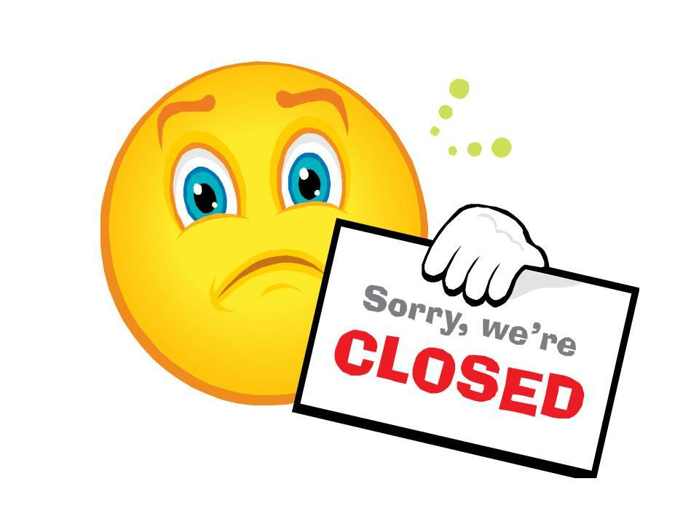

PRACTICE TRAINING DAYS

We will be closed from 12 noon on the following days.

If you need to see or speak to a doctor

please call Freephone NHS 111

• **Thursday 16th January 2020**

• **Thursday 20th February 2020**

• **Thursday 19th March 2020**

• **Thursday 17th April 2020**

• **Thursday 21st May 2020**

• **Thursday 18th June 2020**

• **Thursday 16th July 2020**

• **Thursday 20th August 2020**

• **Thursday 17th September 2020**

• **Thursday 15th October 2020**

• **Thursday 19th November 2020**

• **Thursday 18th December 2020**